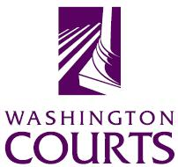 administrative office of the courts

September 18, 2019

TO: Judges, Commissioners, County Clerks, Superior Court Administrators, Juvenile Court Administrators, Law Libraries, Attorneys, and Public

FROM: Merrie Gough, Senior Legal Analyst

SUBJECT: 2019 SUMMARY OF CHANGES TO JUVENILE COURT FORMS

The Juvenile Court Forms Subcommittee and the Washington Pattern Forms Committee updated the Juvenile Court Forms listed below to implement:
- Laws of 2019, ch. HB 1900
The changes go into effect October 1, 2019.
Detailed descriptions of the changes follow:
Dependency Proceedings – JU-3
 | JU 03.0450 | Motion for Court Approval of Placement in a Qualified Residential Treatment Program  New form.
 | JU 03.0460 | Order on Motion for Court Approval of Placement in Qualified Residential Treatment Program  New form.
 | JU 03.0500 | Order after Hearing First Dependency Review / Dependency Review / Permanency Planning  See paragraph 2.15.
 | JU 03.0560 | Legally Free – Order after Hearing Dependency Review / Permanency Planning  See new paragraph 2.14.

